**INTRODUCTION TO VERSION CONTROL EXERCISE**

**Q1.** Git Setup <https://confluence.atlassian.com/bitbucket/set-up-git-744723531.html>

Ans.-

* Install git using command sudo apt-get install git
* Check version using git –version
* Generate key with ssh-keygen
* Copy public key from the file id_rsa.pub
* Add and create remote access with github by adding public key

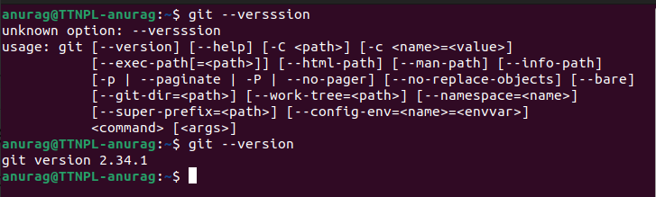

Q2. - Initialize a Git Repository

Ans. - git repository is initialised using git init command

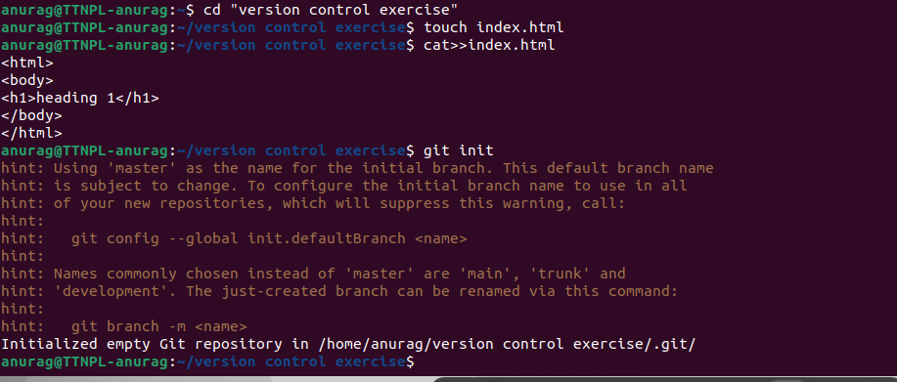

Q3. Add files to the repository

Ans. - add files in a repository with ‘ git add . ’ for all files and ‘ git add file1 file2 file3 …’ for the files we want to add to repo.

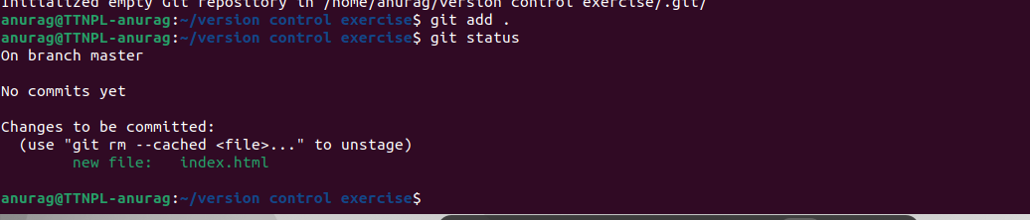

Q4. - Unstage 1 file

Ans. - If we want not to include a staged file file in next commit we must unstage it using git rm –cached filename command and it will not be included in the next commit.

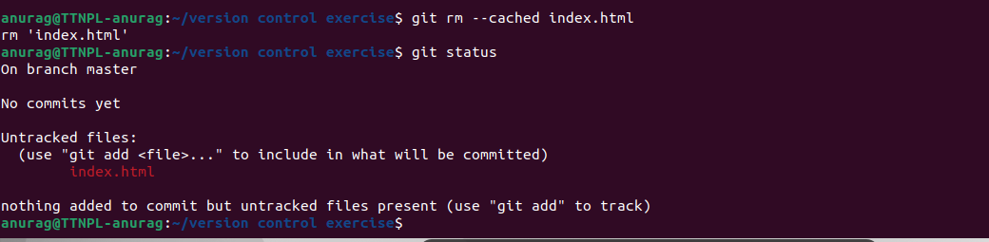

Q5. - Commit the file

Ans. - committing a file means to save the updated.

It is done using git commit command with a message followed by -m.

=> git commit . -m "message while coming file”.

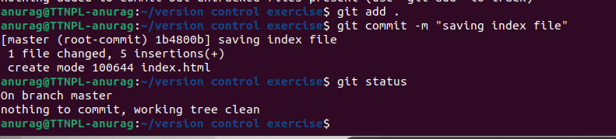

Q6. - Add a remote

Ans. - remote origin can be added to git repository using fit remote add origin url_of_repo.

=> git remote add origin [git@github.com](mailto:git@github.com):anurag-ttn/exercise-intro-to-git.git in my case.



Q7. - Undo changes to a particular file

Ans. - ?

Q8. - Push changes to Github

Ans. - after adding the remote origin we can push our changes to the github by using the command git push -u origin main.

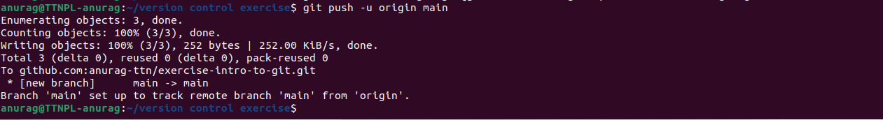

Q9. - Clone the repository

Ans. - git clone command is used to clone a particular repository from github or any other platform using the url of the repository and open that repo in local machine using secure shell protocol.

=> git clone [git@github.com](mailto:git@github.com):anurag-ttn/intro-to-git-bootcamp.git

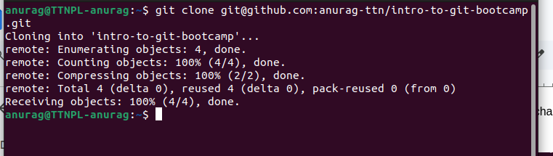

Q10. - Add changes to one of the copies and pull the changes in the other.

Ans. -

Q 11. - Check differences between a file and its staged version

Ans. - In staged version git status shows the files name in green color marked as changes to be committed

before adding file to git it shows file name as untracked changes.

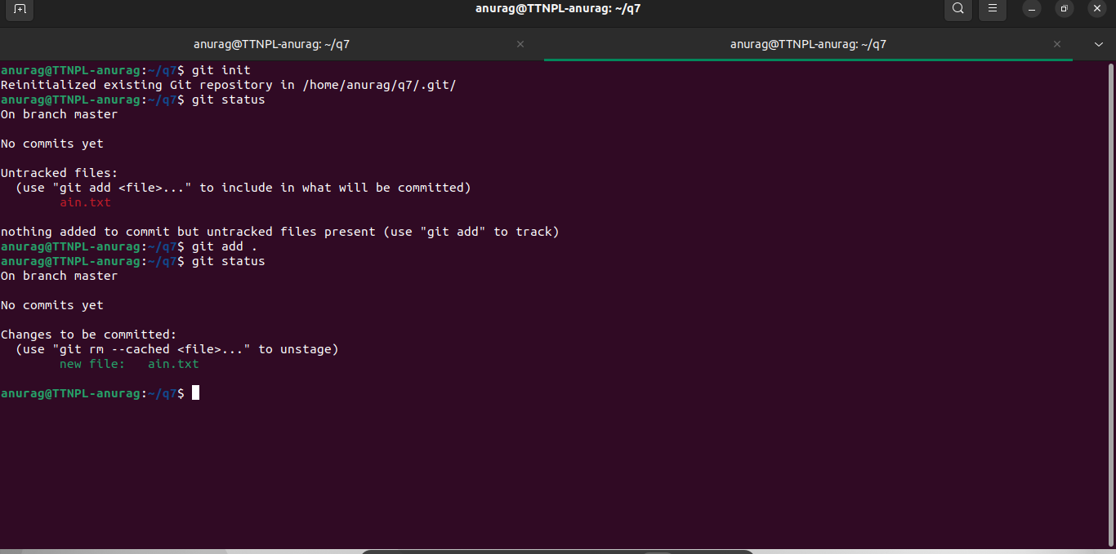

Q12. - Ignore a few files to be checked in

Ans. - files in git can be ignored by writing name the files which to be ignored in .gitignore file and then add all files but few files are automatically ignored and not added in git repository.

In the following repository f1.txt and f2.txt are in .gitignore thus they are not added in git repo.

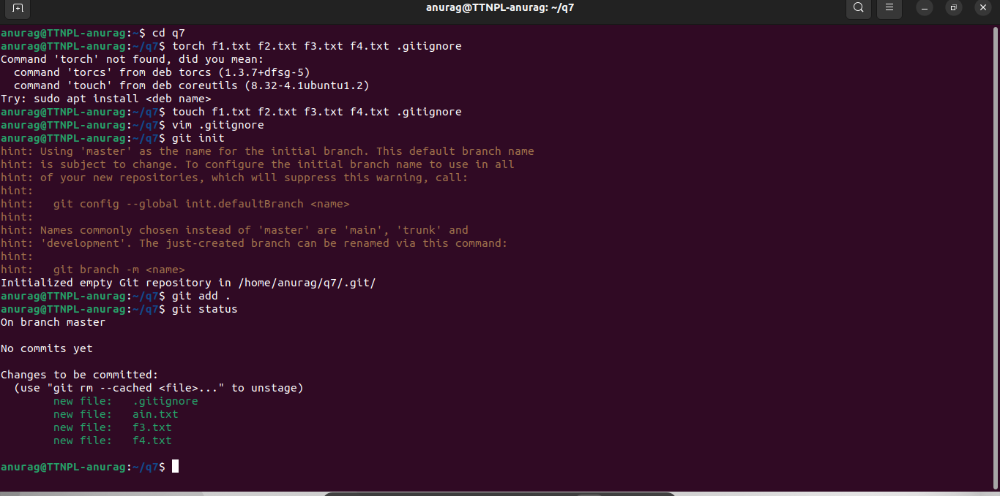

Q13. - Create a new branch

Ans. - new branch can be added with ‘ checkout -b ‘ command with the name of the new branch

=> git checkout -b newbranch



Q14. -

Q15.- Edit the same file at the same line on both branches and commit

Ans. - create a text file in the main branch and write a line in that file then init git , add the file in git , commit the changes to repo . create a new branch using checkout -b and edit the first line of the same file then init git , add file and commit them and move to main branch and try to merge after editing the first line of same file it will give a merge conflict.

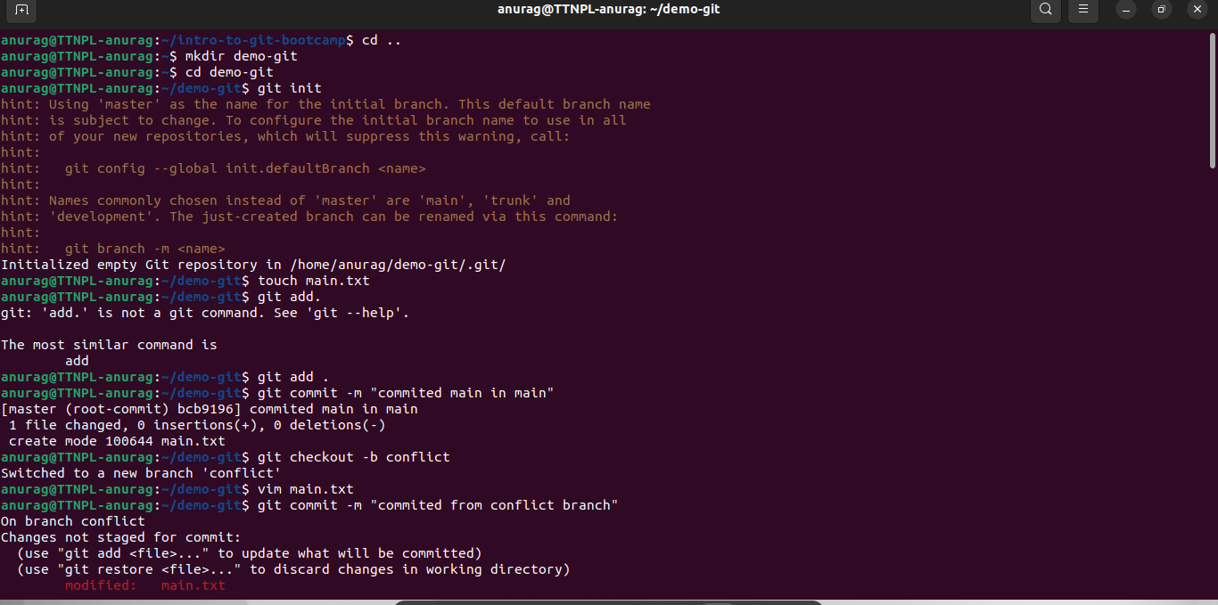

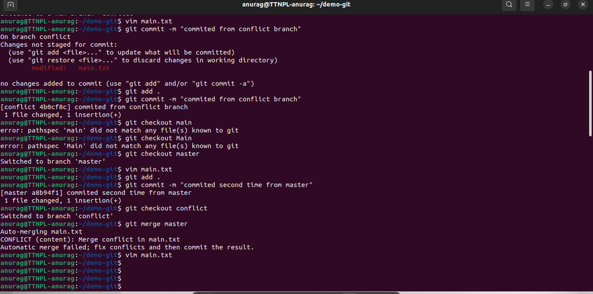

Q16. - Try merging and resolve merge conflicts

Ans. - when trying to merge files from another branch using “ git merge master” it gives merge conflict in the file which can be solved by opening the file in vim editor and remove unnecessary edit from the file and save it which resolves merge conflict.

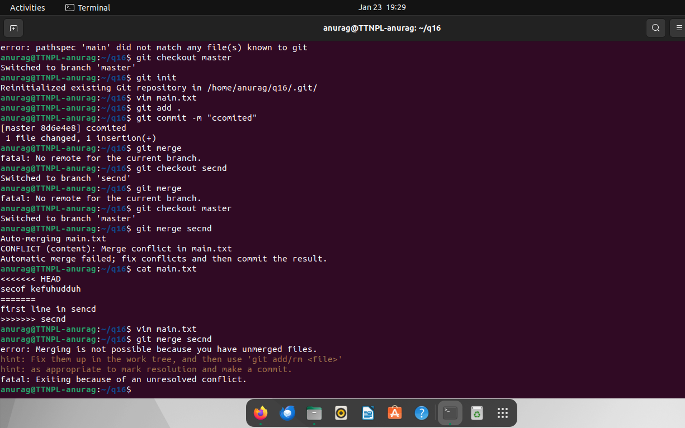

Q17. - Stash the changes and pop them

Ans. - stash is a kind of operation in which work is saved for the current working directory and makes the git index empty for other use. we can do our other task using git then come back after completing to previous task and resume where we left using “ git stash pop “ command and resume.

?

Q18.

Ans. - 